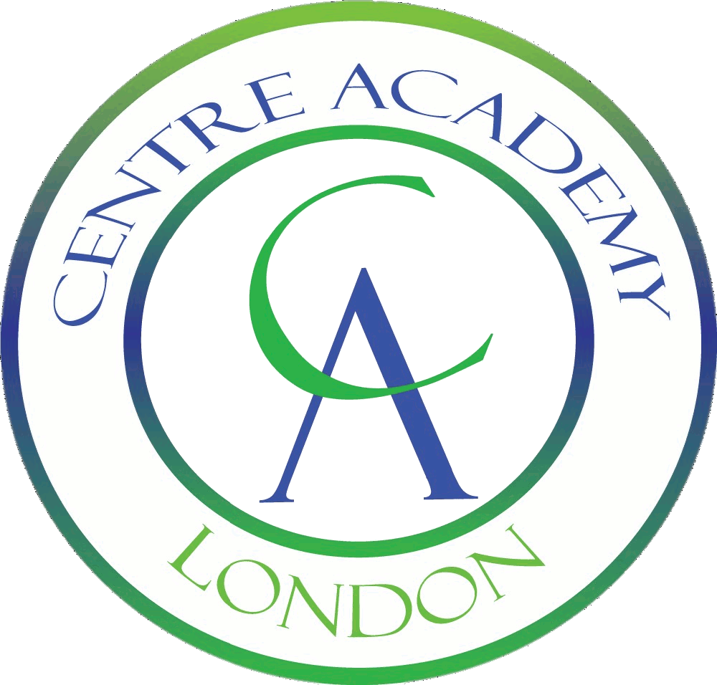
Centre Academy London: GCSE Result Summary 2019

Whilst not all of our students take GCSEs, those on our academic pathway are supported to ensure they have the best chance of success within the national examination framework. Our GCSE results over the past four years:
GCSEs Results | % of A*/9 to C/4 | % of A*/9 to G/1
2018/2019 | 86% | 100%
2017/2018 | 67% | 100%
2016/2017 | 43% | 100%
2015/2016 | 74% | 100%

