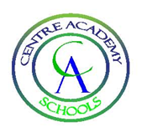
Week Gone/Ahead – 19th November 2021
Centre Academy London (CAL)
Dear Parents/Carers, Students & Staff,
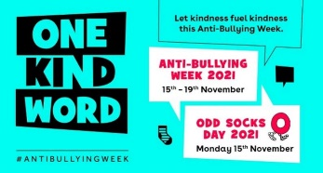
Anti-bullying Week
This week the students have revisited what constitutes as bullying. They have discussed and explored the different types of bullying, sexual language and harassment, and derogatory language.
The emphasis, as always in our school, is to be kind. We believe that it takes great strength to be kind to others, particularly when they have been unkind to us; however, we have also looked at strategies of how to deal with bullies and where to seek help, whether it be in school or out of school. Attached to this week’s newsletter is a parent pack and another National Online Safety flyer about 10 ways to be kind when online.
We started our week off with an odd sock day to celebrate the fact that we are all unique. Some of our staff joined in too and I have to say there was some questionable taste in style! Me included. Great fun though.
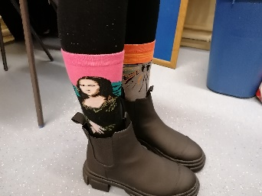
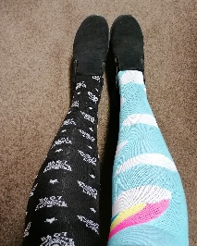

We finished our Anti-bullying week with an excellent PowerPoint presented by our HSD students during assembly.
As a school, we know we have still work to do regarding derogatory language, homophobic language and cyber-bullying and will continue to do so for the remainder of the year. Our students also completed a questionnaire, the results of which I hope to share with you in the next few weeks.
House tokens and Kindness award
Wandle Falcon Effra
3rd
1st
2nd

Head of School Award

10
house points!
Spencer
Spencer is making fantastic progress in all areas of the curriculum and is an excellent basketball player!

Students of the Week

Lewis PE
Jason Maths & Humanities
Farren Current Affairs
Arun Drama
Dionte English
Alfred Art & Mentor
Louise Science
Spencer PE
Jake Science & Humanities
Evan Humanities
Dash Maths
Ethan Science
Joe Humanities
Jack Swimming
Oliver Humanities
Jack Science

Kindness nominations:
Dionte, Farren, Jason, Faris, Noah A, Callum, Ethan, Evan, William, Jules, Freddie, Dash, Alois, Kurt, Jack K

“Kindness beings with the understanding that we all struggle.”
Charlies Glassman

Staff spotlight
Ms Treanor
Sadly, one of our temporary teachers Miss Frances Treanor is leaving to return home to Ireland and hopefully, to do some more travelling around the world as the pandemic eases. We shall miss our lovely Miss Treanor who has been a super addition to our team. A trained art teacher, she has impressed us with her talent and her amazing ability to bake superb cakes. The staff room biscuits will look meagre in comparison now. Bon Voyage Miss Treanor.

Mr Winship
A warm welcome to a new member of staff Mr Lee Winship. Mr Winship is a PE specialist who not only will enhance our PE provision but will teach History and Humanities in our school. A teacher of over 25 years in experience, having taught in both primary and secondary schools, mainstream and independent, in both the UK and abroad. Although he has only been with us two days, he feels part of the CAL family already. I know some of your children have had fun with him this week on the basketball court!

Gallery

Students in Phelps created some Bob Ross inspired paintings.
“Robert Norman Ross was an American painter, art instructor, and television host. He was the creator and host of The Joy of Painting, an instructional television program that aired from 1983 to 1994 on PBS in the United States, Canada, Latin America, and Europe”

Christmas Card competition winners!
Sonny and Marjie are our winner and runner up. Look out for their amazing artwork as Sonny’s picture will be our official CAL Christmas card and Marjie’s artwork will be used on our stationery and banner on our website.
Both winners have won 50 and 25 tokens respectively for their houses but also a voucher each to perhaps spend on more art supplies?

Well done to you both.

Upcoming events
26.11.21 British Museum Trip

Parent feedback
Please continue to email us at:
Londonschool@centreacademy.co.uk.

Have a lovely weekend.

Kas Lee-Douglas
Head of School

